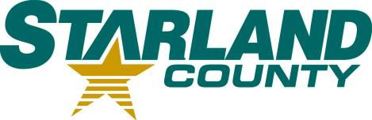STARLAND COUNTY COUNCIL MEETING AGENDA

DECEMBER 11th, 2024

# CALL TO ORDER

1. **REVIEW & APPROVAL OF THE AGENDA**
   1. Additions or Amendments to the Agenda

*Motion to Approve the Agenda as (presented/amended)*

# APPROVAL OF THE MINUTES

* 1. November 27th, 2024 Regular Meeting of Council Minutes

*Motion to adopt* November 27th*, 2024, Regular Meeting of Council minutes as (presented/amended)*

# APPROVAL OF ACCOUNTS

* 1. Motion to Approve Accounts

# APPROVAL OF THE FINANCIAL STATEMENT

* 1. No item

# DELEGATION

# Gene Caswell

# NEW BUSINESS

* 1. 2025 Interim Budget
  2. RCD - Asset Management and GIS Specialist Role

# OLD BUSINESS

* 1. Bylaw 2007

# OTHER

* 1. No item

# STAFF REPORTS

* 1. CAO Report

*Motion to receive CAO Report for Information.*

# COUNCIL COMMITTEE REPORTS 11.1. No item

# COUNCIL COMMUNICATIONS

* 1. Letter for Municipal Support for the Red Deer River Watershed Alliance
  2. Notes to Council – Marigold Library System
  3. FCM – Reply to Wheatland County
  4. Letter from the Minister of Municipal Affairs – RMA Follow-up

# COUNCIL CALENDAR

* 1. January 2025

# CLOSED SESSION

* 1. No item

# ADJOURNMENT