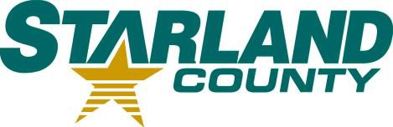STARLAND COUNTY COUNCIL MEETING AGENDA

NOVEMBER 27th, 2024

# CALL TO ORDER

1. **REVIEW & APPROVAL OF THE AGENDA**
   1. Additions or Amendments to the Agenda

*Motion to Approve the Agenda as (presented/amended)*

# APPROVAL OF THE MINUTES

* 1. November 13th, 2024 Regular Meeting of Council Minutes

*Motion to adopt* November 13th*, 2024, Regular Meeting of Council minutes as (presented/amended)*

# APPROVAL OF ACCOUNTS

* 1. Motion to Approve Accounts

# APPROVAL OF THE FINANCIAL STATEMENT

* 1. October Financial Statement

# DELEGATION

# Sgt. Robert Harms

# NEW BUSINESS

* 1. RCMP Provincial Report for Q2
  2. Request for Decision – ISDAB Partnership
  3. Bylaw 2008 – Palliser ISDAB Bylaw
  4. Community Grants
  5. Letter to The Honourable Senators of Canada – Bill C-392
  6. Request for Decision - Wastewater Flood and Drought Resiliency Assessment Funding

# OLD BUSINESS

* 1. Bylaw 2005 – Municipal Services Fee Schedule

# OTHER

* 1. No item

# STAFF REPORTS

* 1. CAO Report

*Motion to receive CAO Report for Information.*

# COUNCIL COMMITTEE REPORTS 11.1. No item

# STARLAND COUNTY COUNCIL MEETING AGENDA – November 27th, 2024

# COUNCIL COMMUNICATIONS

* 1. Memo from Minister of Technology and Innovation regarding Bill 33
  2. Memo from Minister of Service Alberta and Red Tape Reduction

# COUNCIL CALENDAR

* 1. No item

# CLOSED SESSION

* 1. No item

# ADJOURNMENT