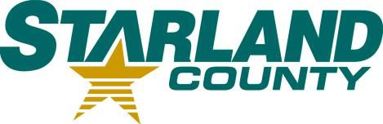STARLAND COUNTY COUNCIL MEETING AGENDA October 23rd, 2024

# CALL TO ORDER

1. **REVIEW & APPROVAL OF THE AGENDA**
   1. Additions or Amendments to the Agenda

*Motion to Approve the Agenda as (presented/amended)*

# APPROVAL OF THE MINUTES

* 1. October 9th, 2024 Council Meeting Minutes

*Motion to adopt October 9th, 2024 Council minutes as (presented/amended)*

# APPROVAL OF ACCOUNTS

* 1. Motion to Approve Accounts

# APPROVAL OF THE FINANCIAL STATEMENT

* 1. September Financial Statement

# DELEGATION

# No item

# NEW BUSINESS

* 1. Amending Bylaw 2005
  2. Revising Bylaw 2006
  3. Fall RMA Resolutions
  4. PERC/DIRC Applications

# OLD BUSINESS

* 1. Amendment of the Minutes – September 11th

# OTHER

* 1. Review of Bylaw 1187 - Councillor Code of Conduct
  2. RCD – Staff Attendance of RMA Convention

# STAFF REPORTS

* 1. CAO Report

*Motion to receive CAO Report for Information.*

# COUNCIL COMMITTEE REPORTS

* 1. No item

# STARLAND COUNTY COUNCIL MEETING AGENDA – October 23rd, 2024

# COUNCIL COMMUNICATIONS

* 1. No item

# COUNCIL CALENDAR

* 1. No item

# CLOSED SESSION

* 1. No item

# ADJOURNMENT