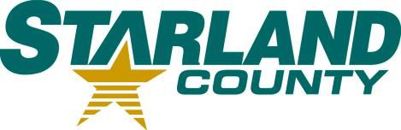STARLAND COUNTY COUNCIL MEETING AGENDA

January 8th, 2025

# CALL TO ORDER

1. **REVIEW & APPROVAL OF THE AGENDA**
   1. Additions or Amendments to the Agenda

*Motion to Approve the Agenda as (presented/amended)*

# APPROVAL OF THE MINUTES

* 1. December 8th, 2024 Regular Meeting of Council Minutes

*Motion to adopt December* 8th*, 2024, Regular Meeting of Council minutes as (presented/amended)*

# APPROVAL OF ACCOUNTS

* 1. Motion to Approve Accounts

# APPROVAL OF THE FINANCIAL STATEMENT

* 1. November Financial Statement

# DELEGATION

# No item

# NEW BUSINESS

* 1. Brownlee Emerging Trends
  2. FCM Membership
  3. FCM Convention RCD
  4. Appointment of the Ag Pest and Soil Appeal Board
  5. Motion to Cancel the January 22, 2025 Regular Meeting of Council

# OLD BUSINESS

* 1. PERC/DIRC Application

# OTHER

* 1. No item

# STAFF REPORTS

* 1. CAO Report

*Motion to receive CAO Report for Information.*

# COUNCIL COMMITTEE REPORTS 11.1. No item

# COUNCIL COMMUNICATIONS

* 1. No item

# COUNCIL CALENDAR

* 1. February 2025

# CLOSED SESSION

* 1. No item

# ADJOURNMENT